HYDE PARK
8 Northgate Street
Unley Park
SA 5061

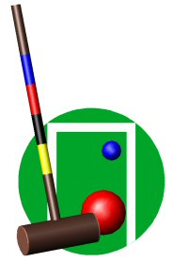
CROQUET
CLUB

APPLICATION FOR MEMBERSHIP

NAME: …………………………………………………..

ADDRESS: …………………………………………………..

…………………………………………………..

Date / Year of Birth ……………………………….

CONTACT Ph …………….………………………..
DETAILS
Email ……………………………………….

Name of existing members supporting the application (two required):

- ………………………………… 2 …………………………………

Name and details of someone to contact in case of emergency (not to be published)

Name …………………………… Details ….……………………………

If transferring from another club your handicap:- ……. & SACA registration no. ….……

NB Please tick this box to indicate that you are prepared for your contact details to be included in a listing of members, made available to members for the purpose of contacting one another.

Your application will be provided to the committee for consideration at the earliest opportunity. In the meantime, please feel free to use our facilities as our guest. Information on your application will be stored confidentially.

For your information, a financial member of the Hyde Park Croquet Club is automatically a member of the Unley Park Sports Club.

A member of HPCC is required to be a member of the South Australian Croquet Association.

